BORCS!

DESIGN DOCUMENT

Introduction 2
Game Summary 2
Inspiration 2
Player Experience 2
Platform 3
Development Software 3
Genre 3
Target Audience 3
Concept 3
Gameplay overview 3
Theme Interpretation (Sacrifice Is Strength) 4
Primary Mechanics 4
Secondary Mechanics 5
Art 6
Theme Interpretation 6
Design 6
Audio 7
Music 7
Sound Effects 7
Game Experience 7
UI 7
Controls 7
Development Timeline 8

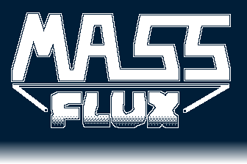

Introduction

Game Summary Pitch
BORCS! is a 2D top-down game that combines aspects of the classic block breaker style game with the rogue-like genre.

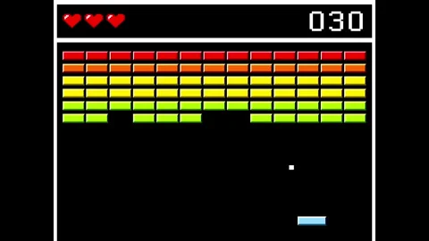
Inspiration
Classic Block Breaker
Block Breaker is a classic arcade game with simple mechanics and physics and provides a good base to build on with other enjoyable mechanics and story.

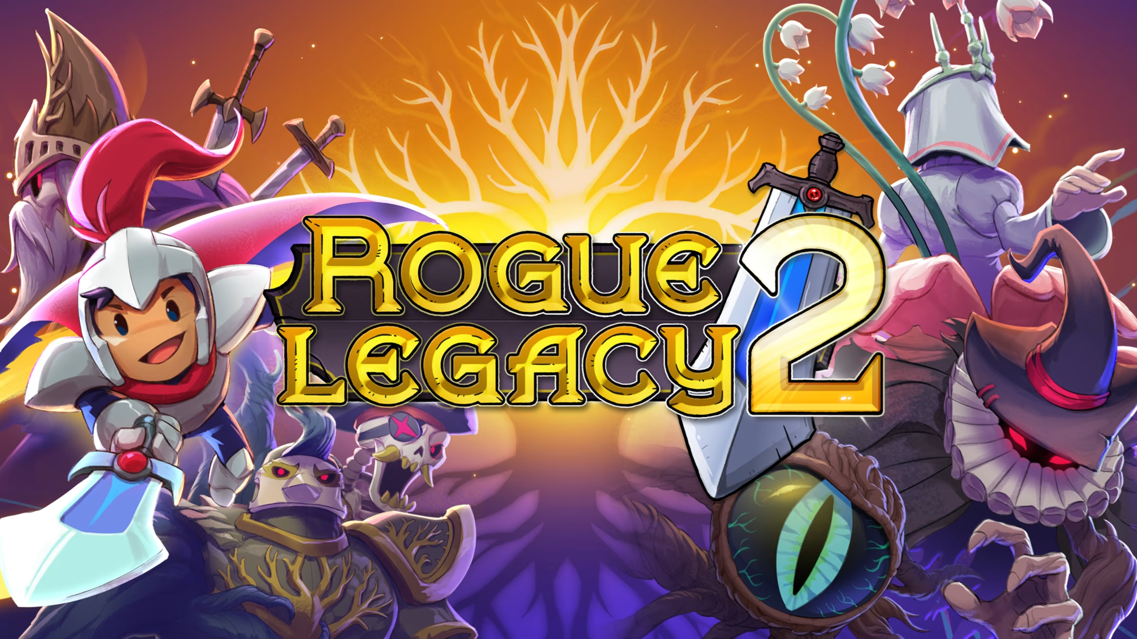
Rogue Legacy 2
Rogue Legacy 2 is a game that I personally cannot get enough of. The story and the game play are engaging and fun, and the challenge is constantly enthralling.

Player Experience
Each level will consist of the “bouncypult” that the player will move (on screen pushed by the player’s units) in order to bounce the moving ball back across the screen. This ball will hit the enemy’s fortifications and buildings. As the enemy structures are damaged and destroyed, the player will “raid” (or it will appear when the structure is destroyed) the structures for money and materials to upgrade their units and bouncypult.

Platform
The game is developed to be released on windows PC

Development Software
- Godot 4.3 for programming
- Aseprite for graphics and UI
- FL Studio 12 for all music and SFX

Genre
Singleplayer, rogue-like, casual

Target Audience
Without heavy or complicated ideas, and intuitive-to-grasp mechanics, this game is marketed to casual game players.

Concept

Gameplay overview
Each level will consist of the “bouncypult” that the player will move (on screen pushed by the player’s units) in order to bounce the moving ball back across the screen. This ball will hit the enemy’s fortifications and buildings. As the enemy structures are damaged and destroyed, the player will “raid” (or it will appear when the structure is destroyed) the structures for money and materials to upgrade their units and bouncypult.

Primary Mechanics

Mechanic | Animated Mockup  (Art not necessarily final)
Walls
A stopping force to prevent the ball from going off screen. May remove to increase difficulty.
Ball
The bouncypult ball that bounces around the screen and cause destruction to enemy structures.
Bouncypult
Catapult like device that launches a ball and then bounces it back into enemy structures when it returns.
Spikesa
Enemy trap that can stop or slow your ball???
Pits
Cause the ball to drop into a hole in the ground and the player must launch a new ball.
Money
Player will find money in destroyed structures, this will be used for upgrades at the beginning of each run.

Art

Design
A cartoony approach to the artwork will give the game a casual and fun atmosphere.

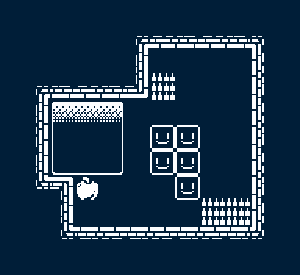
*Not an actual puzzle/level, merely a full example of the tileset and art style*

Audio

Music
Light, casual ambience music will be used throughout the game, to match the casual atmosphere.

Sound Effects
Sound effects will be the bulk of the audio work, as we will want several effects to match up with the sounds of the bouncypult, the ball hitting structures, structures collapsing, units heaving the bouncypult, and any other background effects.

Game Experience

UI
The UI will match the cartoony and casual atmosphere of the game, possibly incorporating a medieval parchment style.

Controls
Keyboard
Arrow keys / WASD

Mouse
Mouse movement left/right
Gamepad
Dpad

Development Timeline

MINIMUM VIABLE PRODUCT

# | Assignment | Type | Status | Finish By | Notes
1 | Design Document | Other | In progress | Jan 15, 2025
2 | Create player and wall assets | Art | Not started | Jan 30, 2025 | Prototype for GDD is done
3 | Main menu theme | Audio | Not started | Jun 30, 2025 | Can be really short, player won’t be on main menu for long
4 | UI / Main menu | Coding | In progress | Jan 30, 2025 | Button UI, screen transition, title screen
5 | Level theme | Audio | Not started | Jun 30, 2025 | Should be more substantial and not annoying
6 | Simple player movement | Coding | In progress | Jan 30, 2025 | Sliding bar to bounce the ball.
7 | Complex player movement | Coding | Not started | Feb 28, 2025 | Changing the shape of the bar and differing physics for a moving or still bar, possibly incorporate material changes (wood, stone, etc)
8 | Ball interactions with structures | Coding | In progress | Jan 30, 2025 | Implement ball hitting and breaking structures
9 | Enemy interactions | Coding | Not started | Mar 30, 2025 | Implement enemy units attacking the ball and bouncypult. How does a player fail and end the run?
10 | Special effects | Art | Not started | Apr 30, 2025 | Dust particles during movement, tracks as the ball rolls through grass
11 | Player animation | Art | Not started | Mar 30, 2025 | Unit movements, ball rolling
12 | Sound effects | Audio | Not started | Apr 30, 2025 | Player movement, UI interaction
13 | Pause menu | Coding | In progress | Feb 28, 2025 | Access to the main menu or resetting the level
14 | Level select menu | Coding | In progress | Feb 28, 2025 | Use map or buttons?
15 | Level design (1-7) | Other | In progress | Mar 30, 2025 | Create levels 1 through 7
16 | Level design (8-15) | Other | Not started | Jun 30, 2025 | Create levels 7 through 15
17 | Logo and Intro screens | Other | Not started | Jun 30, 2025 | Finch House Logo, Godot screen, any other logos…
18 | Settings Menu | Coding | In progress | Feb 28, 2025 | Volume slider, fullscreen toggle
19 | Any extra polish | Other | Not started | Jun 30, 2025
20 | SUBMIT | Other | Not started | Jul 30, 2025 | Create Itch and Steam Pages and upload

BEYOND (if ahead of schedule / extra time)

Extra levels | Other | Not started

